**CURRICULAM VITAE**

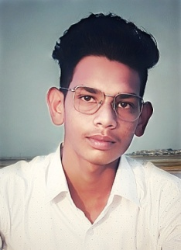

**AKSHAY KUMAWAT**

**Village-Rojdi P.O-Phulera**

**The-Sambar, Dist-jaipur-303338**

**Mob. No. +919887773354**

**Email-** [**akshaykumawat571@gmail.com**](mailto:akshaykumawat571@gmail.com)

**AAdhar card. 887823284854**

**CAREER OBJECTIVE:**

• Looking forward to a position of responsibility in an organization of repute which

stimulates and enhances my professional skills and personal strengths in conjunction

with organizational goals and objectives.

**ACADEMIC QUALIFICATION:**

• 10th Passed From Ajmer Board Rajasthan in the years 2020.

• 12th Appring From Ajmer Board Rajasthan in the years 2022.

**Strengths:-**

✓ **Communication Skill.**

✓ **Confidence Level is high.**

✓ **Hard Work**

✓ **Computer Work**

**COMPUTER SKILLS**

✓ Computer Basic.

✓ Rs-cit Computer

✓ Web Design

HTML,

CSS,

JAVASCRIPT,

BOOTSTRAP

JQUERY

✓ Web Development

PHP

**PERSONAL INFORMATION:**

•   Father’s Name : Mr. Shrawan lal kumawat

•   Mother’s Name : Ganga devi

•   Date of Birth : 15-08-2005

•   Sex : Male

•   Marital Status : Unmarried

•   Nationality : Indian

•   Language Known : Hindi & English

DATE……………….

PLACE……………… **(AKSHAY KUMAWAT )**